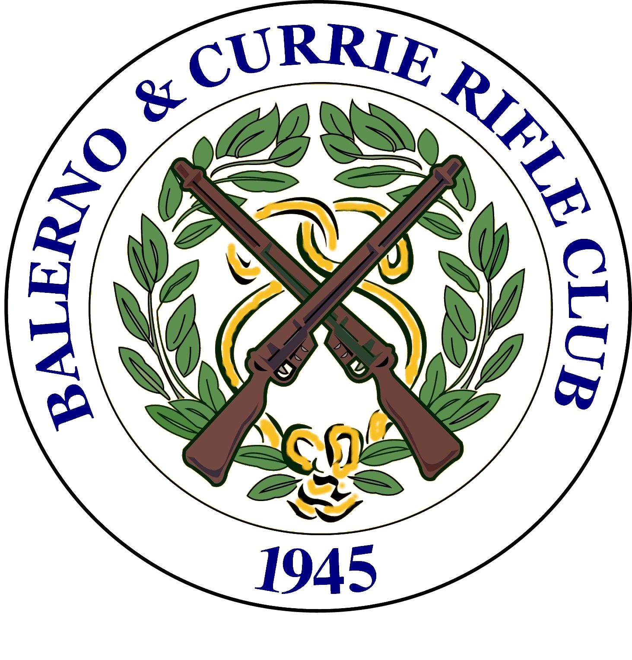  Balerno & Currie Rifle Club  102 Curriehill Road, Currie, Edinburgh | No: [ ]
Open Meeting 2011  Saturday 19th November & Sunday 20th November, 10.00am – 6.00pm | Class: [ ]
Entry Form

Name |  |  | Club
Address |  |  | Date of Birth
 |  |  | Are you left handed?
 |  |  | Club Sec.
 |  |  | Name
Postcode |  |  | Address
Tel (day)
Tel (eve)
Email |  |  | Postcode

Average Declaration

This must be completed unless you are entering Class A. It should be calculated from the best 10 of your last 12 league competition cards, excluding any exceptionally low scores.

Date |  |  |  |  |  |  |  |  |  |  | Average
Comp
Score

Certified by (Club/Match Secretary):

Signed (Competitor) :

Classification |  |  | Competitions
Class A | 97.5 and above |  | Competition 1 | 30 shots
Class B | 95.0 - 97.49 |  | Competition 2 | 30 shots
Class C | 92.5 – 94.99 |  | Competition 3 | Aggregate of Comps 1 & 2
Class D | Under 92.49 |  | Pairs (each) | 20 shots
 |  |  | Junior (under 18) | 30 shots
 |  |  | Team of 3 (each) | 20 shots
Trophies |  |  | Medals (specially struck Balerno & Currie medals)
Class A | Fenwick Electronics Cup |  | Competition 1 | 1st ‘Gold’ Medal
Class B | McLean Cup |  | Competition 2 | 1st ‘Gold’ Medal
Class C | Steele Trophy |  | Competition 3 | 1st ‘Gold’ Medal / 2nd ‘Silver’ Medal / 3rd ‘Bronze’ Medal
Class D | May Cup |  | Pairs (each) | 1st ‘Gold’ Medals
 |  |  | Junior | 1st ‘Gold’ Medal / 2nd ‘Silver’ Medal / 3rd ‘Bronze’ Medal
 |  |  | Team | 3 “Gold” Medals

Entry Details
Comp 1 | 30 shots | £4.00 | £
Comp 2 | 30 shots | £4.00 | £
Comp 3 | Aggregate of comps 1 & 2 | £2.00 | £
 | Deduct 50% if under 18 on day of competition |  | £
Pairs  Partner | 20 shots  [ ] | £2.00 each | £
Team of 3 |  | £2.00 each | £
Junior | 30 shots | £3.00 | £
Total: |  |  | £

Rules:
- Unless otherwise intimated at the meeting, the meeting will be run according to NRSA rules
- Any disputes will be resolved in a meeting of the Range Committee.
- Unlimited sighters will be allowed
- Competitors shoot 1 card per detail
- Details will be 10 minutes duration with 5 minutes to charge targets
- The Range committee reserve the right to reclassify any competitor at any time
- Ammunition will be on sale
- Cards for the Junior competition may be shot concurrently with Comps 1 & 2
- Breech open safety flags are required and will be on sale at the meeting
- In the event of a tie for first place all cards will be re-scored with an air weapons gauge, the highest number of shots covering the ‘spot’ completely will be deemed the winner, all other ties will be decided on countback.
- Practice stickers will be available for sale.

Refreshments:
A range of refreshments, snacks and drinks will be on sale during the meeting.

Please return entry forms to:

Balerno Open Secretary
4/4 Glenogle Road
Edinburgh
EH3 5HW

Please make cheques payable to ‘Balerno & Currie RC’

